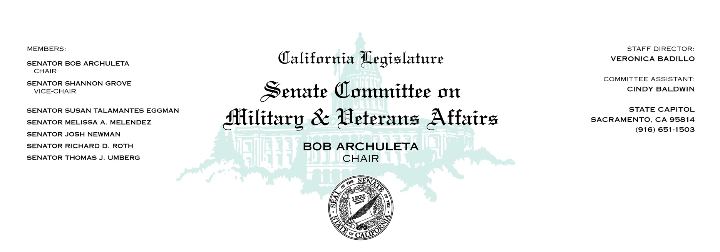

SENATE COMMITTEE ON MILITARY & VETERANS AFFAIRS

CHAIR ARCHULETA

VICE-CHAIR GROVE

July 14, 2021

Upon adjournment of Education Committee

Room 4203

AGENDA

1. AB 107 Salas Licensure: veterans and military spouses

VOTE ONLY

1. AJR 10 Choi Veterans cemeteries: Republic of Korea veterans